**Soldering – II**

**Introduction**

I wanted to get into soldering to bridge the gaps between electronics and code. I feel as though my degree has given few of the practical skills needed to actually create something. This is one of those practical skills. I also wanted to make something nice for my girlfriend CEO that would last. The idea of soldering LEDs onto a PCB with a battery attached made sense.

**Materials**

I’m using a cheap soldering set I found on Amazon. After this project going well, I plan on investing in a more comprehensive setup. For now though I think I’m covered. I’m using safety goggles, a soldering mat, air gun, soldering iron and aluminium, tweezers and other tools for fine motor, no flux because I don’t want to wait.

For the circuit I’m making, I’m placing LEDs in parallel with individual resistors, driven by a 5V Duracell Battery, all soldered onto a Printed Circuit Board, (PCB).

Finally, I cased the board using an old cardboard box with some foam for the display to sit on.

**How to Improve**

Most of the soldering looks okay, (in my opinion), and has held up for the last 6 months. You can almost tell which were done first and had the luxury of flux on the iron. In general, too much solder. This was a partly conscious effort as I wasn’t confident in the connections I was making, particularly toward the end when lack of flux became more of a problem.

I faced some beading issues/ bad connections. To combat this I focused on getting both components as well as the joint as hot as possible. This did the trick.

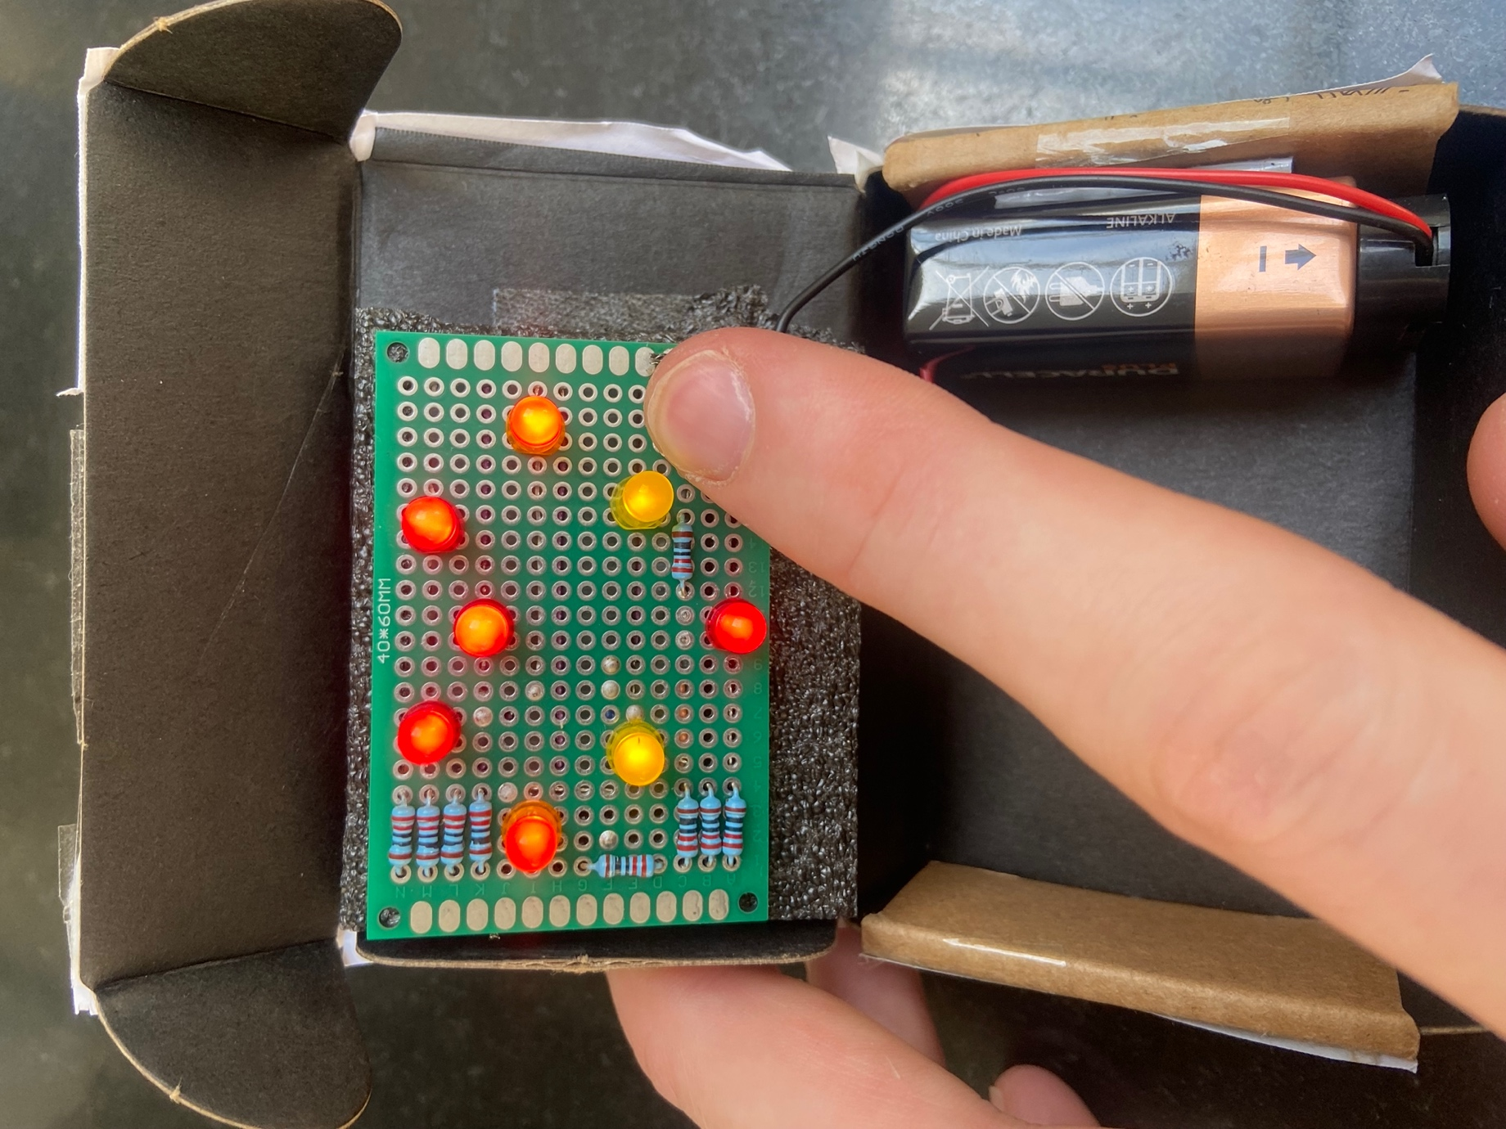

All of the resistors I used were probably not necessary and will likely decrease the life span of the battery. However, I thought it looked cool. The LEDs are also quite bright due to the low res resistors I used (1/2W).

Another idea I had but didn’t want to implement was to use a Raspberry Pi/ Arduino Uno to create a more interesting display. I didn’t want to solder any of my current hardware for fear of fucking it up. I’m going to get some inexpensive RP Zeros for future projects like this.

**Conclusions**

Overall I, and Claire, were very happy with this. It looks clean, shines brightly and has held up over the last few months. The project could do with a little more complexity and maybe some CODE for once. But it was designed for practicality alone.